Covered Device Recycling

April 25, 2026 & October 24, 2026

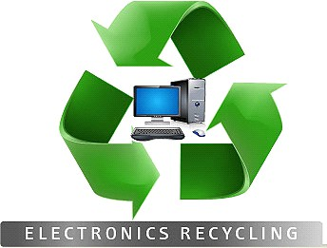
8 to 11 am
NO
Air Conditioners Answering Machines Appliances
Batteries Cameras Cables or Cords Can Openers Cell phones Dehumidifiers Electric Tools Humidifiers Microwaves Radios Refrigerators Shredders
Slide Projectors Speakers Telephones Turntables Vacuums – Rhumba type or otherwise
Accepted items
106 Steelman St
Fairfield Community Fire Co.

For customers of

YES
Computers Copiers Keyboards Modems Monitors Printers Routers Scanners
Stereo receivers Gaming Equipment units, but not their peripherals
*Televisions
*Must be removed from wooden cabinets*
Park’s Garbage Service who live in Carroll Valley & Fairfield Boroughs, & Freedom, Hamiltonban, Highland, & Liberty Townships.

Drive up
No appointment required
Go Recycle!

