# Covered Device Recycling

April 26, 2025 & October 18, 2025

# 8 to 11 am

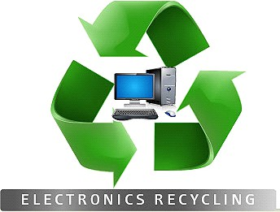

**NO**

Air Conditioners Answering Machines Appliances

Batteries Cameras Cables or Cords Can Openers **Cell phones** Dehumidifiers Electric Tools Humidifiers Microwaves Radios Refrigerators Shredders

Slide Projectors **Speakers Telephones Turntables** Vacuums – Rhumba type or otherwise

**Accepted items**

**31 Carrolls Tract Road**

**For customers of**

**YES**

Computers Copiers Keyboards Modems Monitors Printers Routers Scanners

Stereo receivers Gaming Equipment units, but not their peripherals

*Televisions

*Must be removed from wooden cabinets*

**Park’s Garbage Service** who live in Carroll Valley & Fairfield Boroughs, & Freedom, Hamiltonban, Highland, & Liberty Townships.

# Drive up

No appointment required

Go Recycle!